主题：超市选址

题型：地图

The map below is of the town of Garlsdon. A new supermarket (S) is planned for the town. The map shows two possible sites for the supermarket.

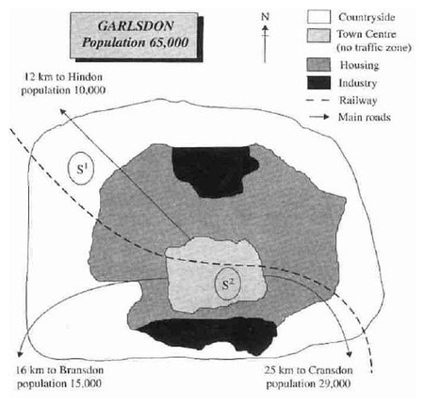

满分范文：

The map shows two potential locations (S1 and S2) for a new supermarket in a town called Garlsdon.

The main difference between the two sites is that S1 is outside the town, whereas S2 is in the center of the town. The sites can also be compared in terms of access by road or rail, and their positions relative to three smaller towns.

Looking at the information in more detail, S1 is in the countryside to the north west of Garlsdon, but it is close to the residential area of the town. S2 is also close to the housing area, which surrounds the town centre.

There are main roads from Hindon, Bransdon and Cransdon to Garlsdon town centre, but this is a no traffic zone, so there would be no access to S2 by car. By contrast, S1 lies on the main road to Hindon, but it would be more difficult to reach from Bransdon and Cransdon. Both supermarket sites are close to the railway that runs through Garlsdon from Hindon to Cransdon.